Criminal Record Check – Applicant - VSC

Date:

To Whom It May Concern,

____________________________, is a volunteer with the Kawartha Cubs Minor Baseball Association (KCMB) out of Lindsay, Ontario. In this capacity, they are required to submit a valid criminal record check with a vulnerable sector check.

This is a volunteer position which will have the applicant directly involved with youth and their development in minor baseball. They will be in direct contact with minor aged persons on a weekly basis. They will be in a position of authority and influence over said persons as they organize and conduct baseball practices, drills, games and overnight tournaments.

The Kawartha Cubs Minor Baseball Association is a member of the Eastern Ontario Baseball Association and Baseball Ontario.

Please consider this official communique from KCMB. Should you require clarification or further information, don’t hesitate to contact me at the below information.

Sincerely,

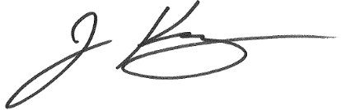

Jamie King
President - KCMB

